


Curriculum Vitae

Name : First : Zeinab Middel: Abdelwahab Surname: Hozien
Position : professor Citizen : Egyptian
Date & place of birth : 5/11/1951 ( Assiut )
Gender :Female
Phone: ++2 -088- 2310241 Mobil: 01223971677 Fax: +2 088 2342708 mail box: 71516
E-mail : dr_hozien@yahoo.com
Address: Assiut University, Faculty of Science, Chemistry Department,
Assiut 71516, Egypt

Academic qualifications
Degree | Date award | University  ( name& Location ) | Specialization
Professor | 2000 | Assiut university | Organic chemistry
Associated prof. | 1995 | Assiut university | Organic chemistry
Ph.D. | 1985 | Assiut university | Organic chemistry
M.Sc. | 1979 | Assiut Univ.(Egypt) | Organic chemistry
B.Sc. | Jun 1974 | Assiut Univ.(Egypt) | Chemistry(major)
Fields of Interest :
Synthesis of Heterocyclic organic compounds
Experiences:
Research working in organic chemistry ,teaching organic chemistry for undergraduate and postgraduate students and supervising the postgraguate students for Ph. D. and M.Sc.degrees.
List of publications: Includes

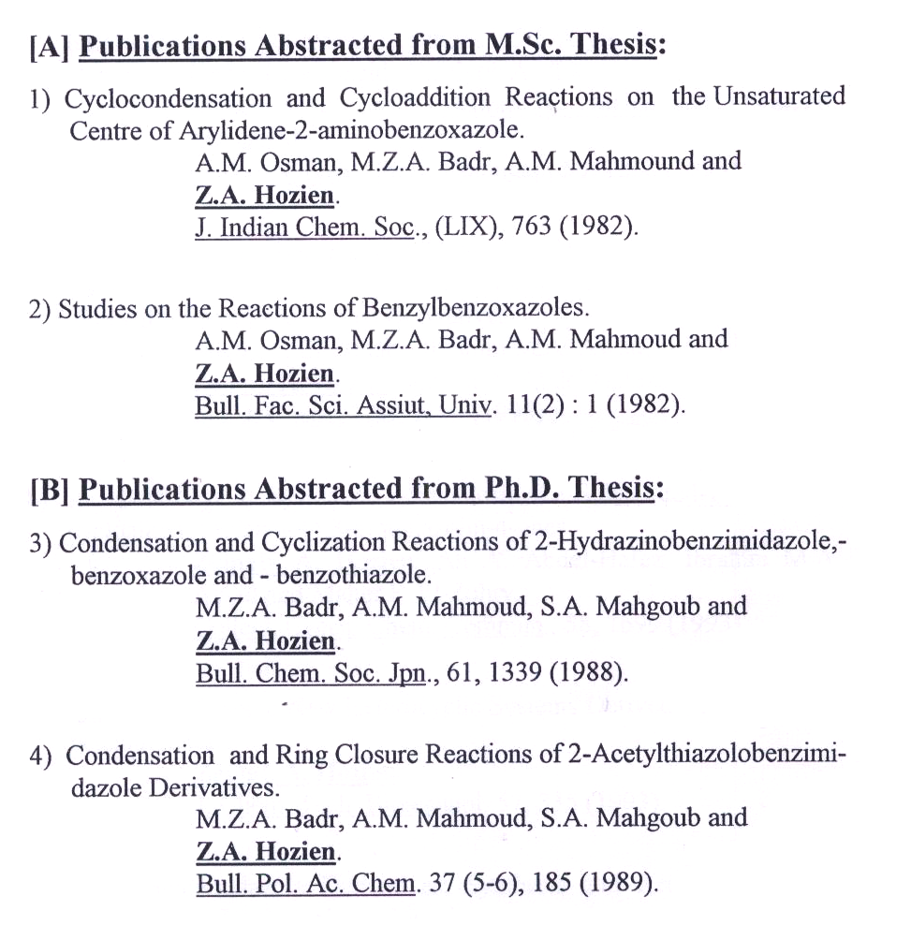

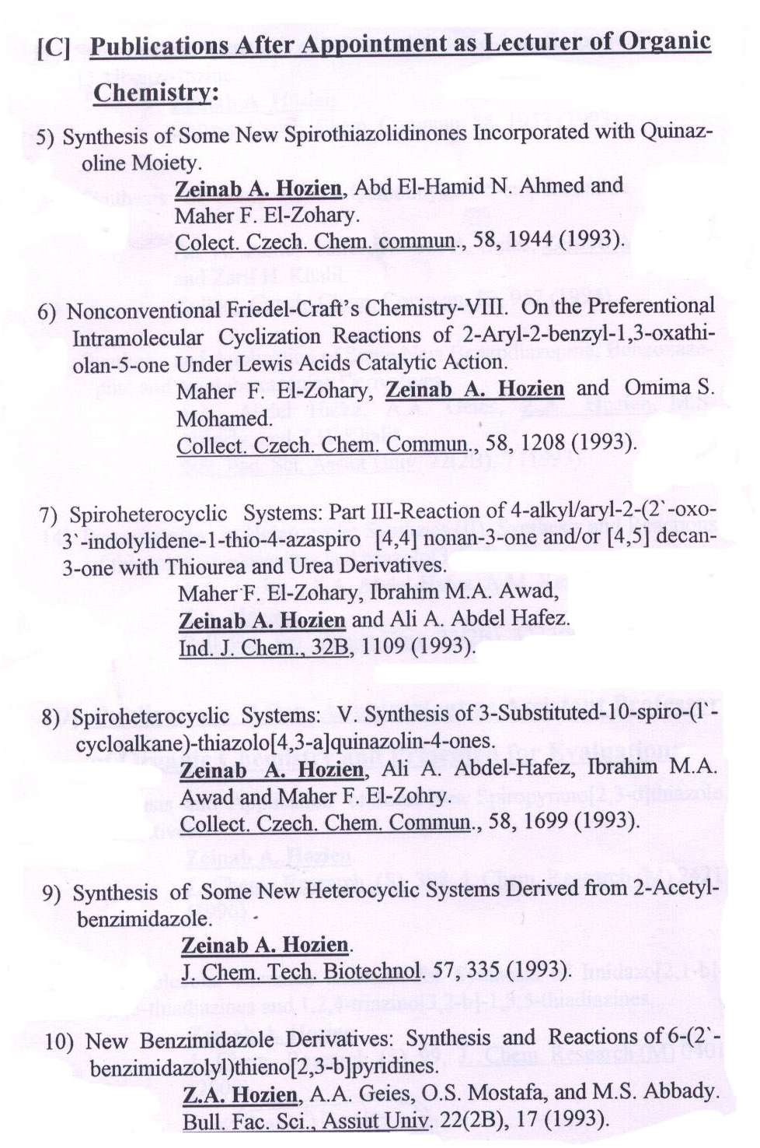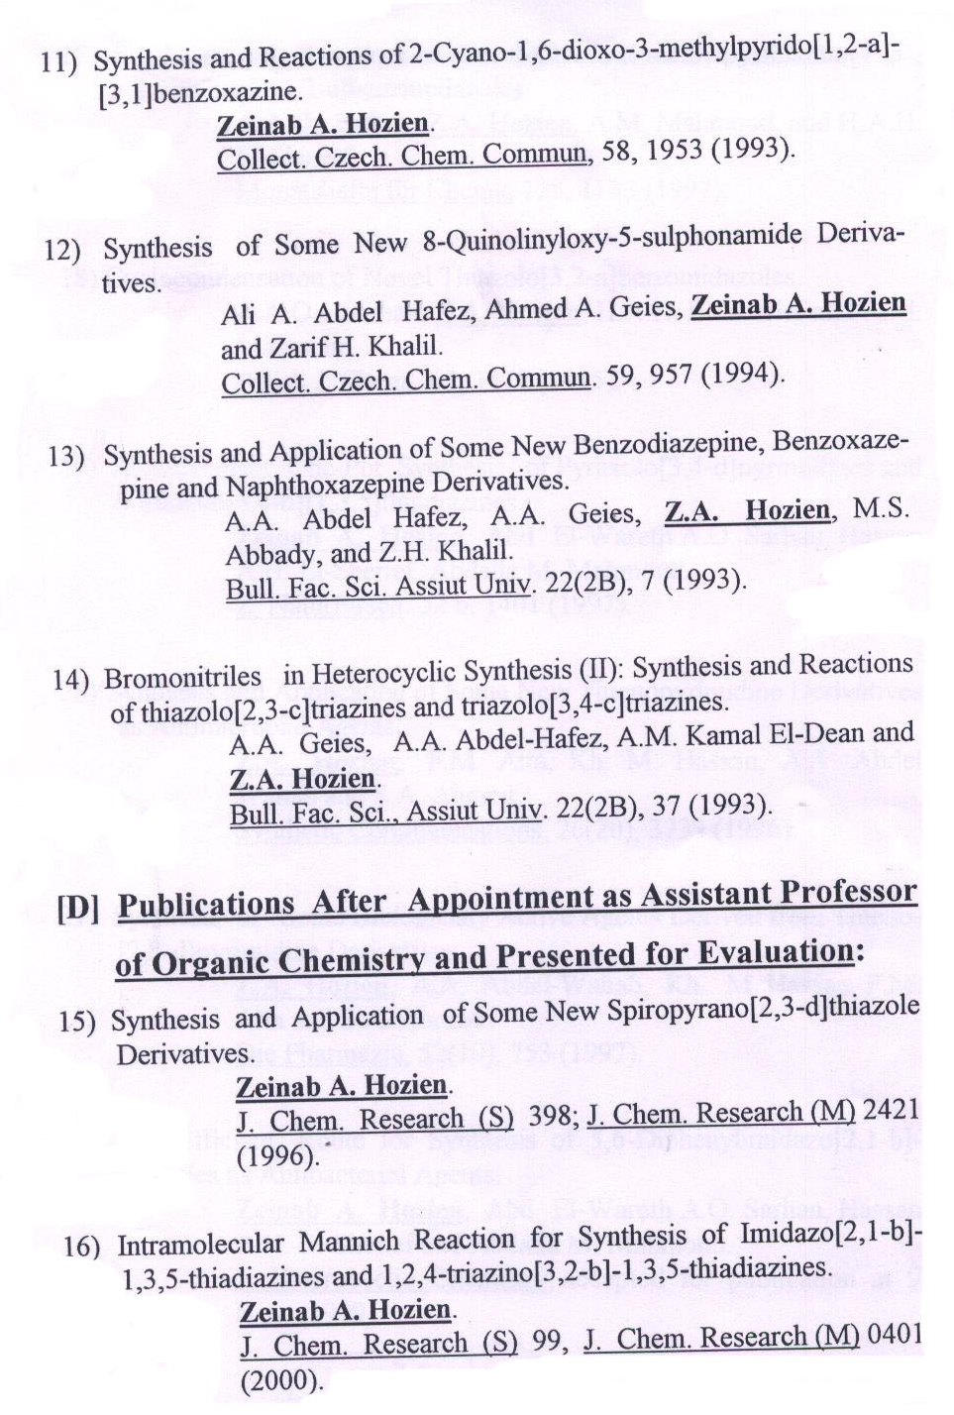

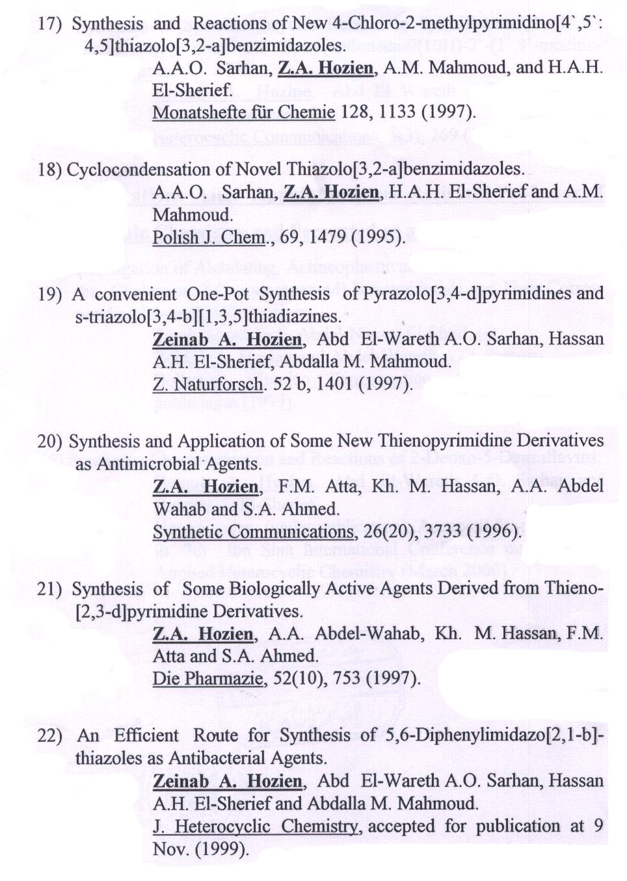
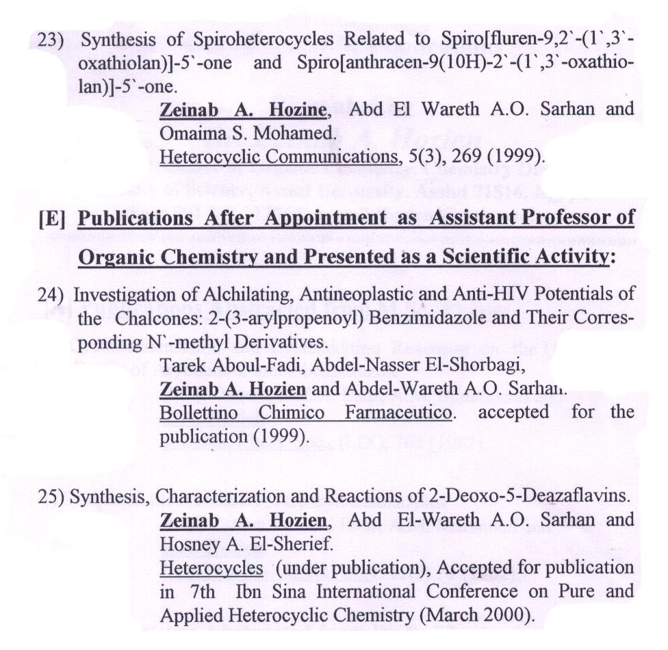
26) One pot Synthesis of Novel thiazolo[3,2-b] [1,2,4] Triazoles : A useful synthesis application of the acidified acetic acid method.
H.A.H.El-Sherief, A.M.M.Mahmoud, A.A.O. Sarhan, Z.A.Hozien and O.M.A.Habib, J.of sulfur chemistry, vol.27,No1, 65-85, 2006 .
27) Studies on the reaction of N-(3-carbethoxy-4,5,6,7-tetrahydrobenzo
[b]thienyl)-N-phenylthiourea with hydrazine hydrate (part1).
Hassan A.H.El Sherief, Gala M.El-Naggar, Zeinab.A.Hozien and
Suliman M.El-Sawaisi. J.Heterocyclic chem.,45,467, 2008.
28) Novel Method for the synthesis of s-triazolo [3,4-b] [1,3,4]
thiadiazines
Hassan A.H.El sherief, Zeinab.A.Hozien, Ahmed F.M. El-Mahdy,
Abdelwareth A.O.Saihan. Synthesis No. 15,2636-2642 (2010).
29) Intramolecular cyclization of Mannich reaction for synthesis of
Pyrimido [2,1-b] -1,3,5- thiadiazines
Hassan A.H.El sherief, Zeinab.A.Hozien, Ahmed F.M. El-Mahdy,
and Abdelwareth A.O.Sarhan. J. Heterocyclic chem. 47,1294 (2010).
30) One pot synthesis and reactions of novel 5-amino [1,3] thiazolo
[3,2-b] [1,2,4] triazoles.
Hassan A.H.El sherief, Zeinab.A.Hozien, Ahmed F.M. El-Mahdy and Abdelwareth A.O.Sarhan, ARKIVOC 71-84 (2011).
31) Photochromism of dihydrolinolizines. Part XVIII: palladium catalyzed Negishi coupling for the synthesis of photochromic dihydro- 5-azaindolizine-linker-conjugates with a terminal ethylene anchoring group. Saleh A.Ahmed, Khalid S.Khairou, Aboel-Magd, A.Abdel-wahab, Zeinab.A.Hozien, Heinz Dum. Tetrahedron letters 4397-4401 (2012).

